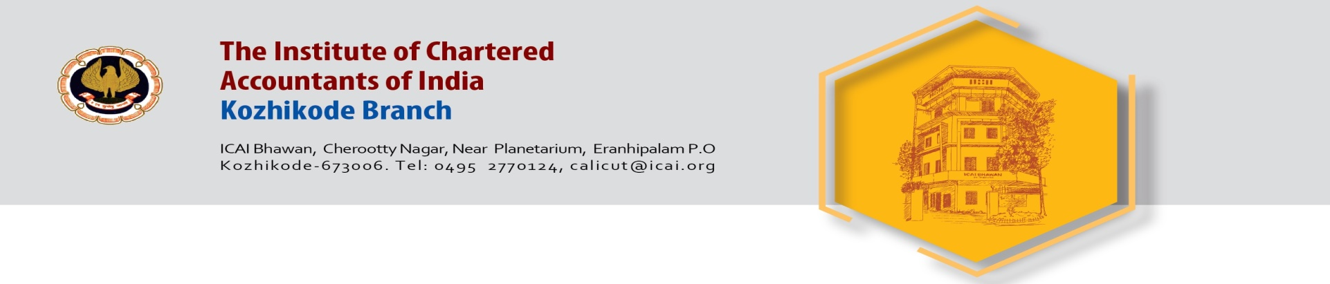

Invite you for a

CPE SEMINAR ON TAX AUDIT

Date : Saturday 21st September 2019

Venue : ICAI Bhawan
Kozhikode

Time : 10 AM to 1 PM

Speaker : CA. Veeramani P.M.
Ernakulam

CPE Credit 3 Hours

Registration Fee including GST :
ICAI ARS (Calicut) Members NIL, ICAI Non ARS (Calicut) Members – 885 /- (KFC extra)

Meeting will be followed by lunch

Sd/- Sd/-
CA. Sarala N. CA. Arun Subramanian
Chairperson Secretary

